DEVELOPMENT OF A MOBILE APPLICATION FOR AUTOMATED PLANT DISEASE DETECTION USING DEEP LEARNING ON LEAF IMAGES
K. V. Klimenko
Novosibirsk State Technical University, Novosibirsk, Russia
Research adviser: A. F. Aleinikov | Language adviser: A. A. Getman

Abstract
Plant diseases threaten crop productivity, and visual diagnosis can be slow or inconsistent. This study evaluates a deep-learning image-classification subsystem designed for a mobile plant-diagnostics application. Using images from PlantVillage and additional photographs, we trained binary healthy/diseased classifiers and crop-specific disease classifiers for six crops. MobileNetV3Large, EfficientNetV2B2, and ResNet50V2 were compared as feature extractors. The binary models achieved a mean test accuracy of 96.88%. The mean accuracy of the MobileNetV3Large categorical models was 84.57%. EfficientNetV2B2 improved results for strawberry and tomato, but required more storage and inference time. The findings support a two-stage classification workflow while highlighting the need to balance accuracy and mobile-device efficiency.
Keywords: plant disease detection, deep learning, image classification, convolutional neural networks, MobileNetV3Large, EfficientNetV2B2, PlantVillage, mobile application.

1. Introduction
Plant diseases reduce yield and quality. Early identification helps growers choose appropriate crop-protection measures, but visual inspection requires experience and may be time-consuming. A mobile tool that analyses a leaf photograph could make preliminary diagnosis more accessible.
Convolutional neural networks (CNNs) have shown strong results in image-based plant disease recognition. Mohanty et al. [1] demonstrated the potential of deep learning on the PlantVillage dataset, while also illustrating the importance of the image domain: performance on controlled images may not transfer directly to field photographs.
Mobile applications impose constraints on model size and inference speed. MobileNetV3 was designed for efficient operation on resource-limited devices [2]. EfficientNetV2 targets improved training efficiency and predictive performance [3], whereas ResNet uses residual connections to support deeper networks [4]. These architectures provide a useful comparison between accuracy and computational cost.
The classification problem can be divided into two stages: first, determine whether a leaf is healthy or diseased; then identify the disease within the selected crop. This structure reduces the number of classes handled by each crop-specific classifier and makes the diagnostic workflow modular.
The aim of this study is to evaluate a deep-learning classification pipeline for a mobile plant-diagnostics application. The experiments compare feature-extraction backbones and classification heads and measure binary and crop-specific classification accuracy for six crops.

2. Materials and Methods

2.1. Dataset and class selection
The initial source was the PlantVillage dataset, containing 54,306 images across 38 classes and 14 crops [1]. After reviewing class coverage, six crops were selected: apple, corn, grape, potato, strawberry, and tomato. The resulting tasks covered 20 disease categories. Table 1 shows the class distribution.
Crop | No. of disease classes | Disease categories
Apple | 2 | Apple scab; black rot
Corn | 3 | Cercospora leaf spot; common rust; northern leaf blight
Grape | 3 | Black rot; Esca (black measles); Isariopsis leaf spot
Potato | 2 | Early blight; late blight
Strawberry | 4 | Angular leaf spot; brown leaf spot; powdery mildew; white leaf spot
Tomato | 6 | Bacterial spot; early blight; late blight; leaf mold; Septoria leaf spot; tomato yellow leaf curl virus

Table 1. Crop distribution in the selected categorical classification tasks.
To make the data less dependent on controlled backgrounds, approximately 100 external photographs were manually added per class. Class imbalance was addressed through random undersampling and augmentation, including rotations, reflections, and brightness changes.

2.2. Image preprocessing and diagnostic pipeline
Before classification, images were processed by the leaf_seg_final segmentation model, a hybrid U-Net with a MobileNetV3Large encoder [5, 6]. Its mask was used only to remove background regions and retain the leaf. The resulting images were resized to 256 × 256 pixels. Segmentation was a preprocessing step; the experiments reported in this article evaluate disease classification.
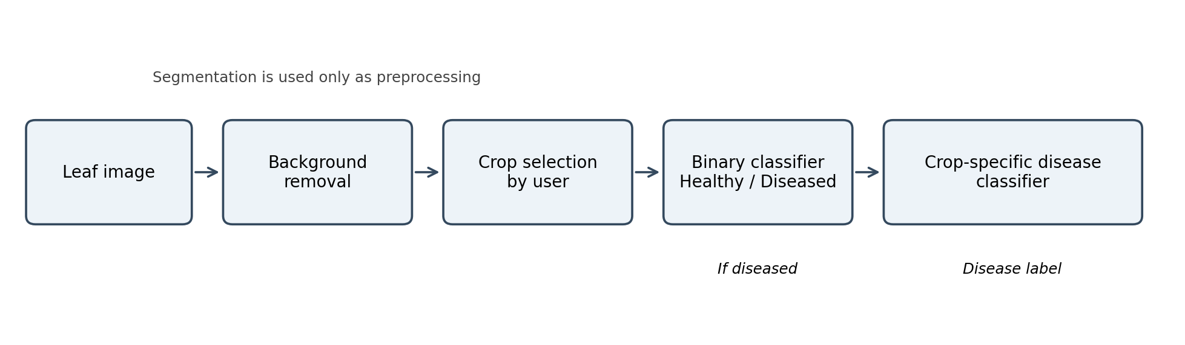
Figure 1. Workflow of the proposed classification subsystem. Segmentation is used for background removal; crop-specific disease classification follows the binary decision.
The workflow has three stages: the user selects a crop; a binary classifier predicts whether the leaf is healthy or diseased; if disease is detected, a crop-specific classifier predicts the disease category. This separates healthy/diseased detection from the more detailed classification task.

2.3. Model architecture
MobileNetV3Large [2], EfficientNetV2B2 [3], and ResNet50V2 [4] were first compared using the same classification head. The comparison used validation accuracy, F1-score, loss, and training time. MobileNetV3Large was retained as the baseline because it offers a compact architecture suitable for mobile deployment.
Backbone | Validation accuracy | Validation F1 | Validation loss | Training time
MobileNetV3Large | 0.9737 | 0.9661 | 0.2414 | 18 min 25 s
EfficientNetV2B2 | 0.9781 | 0.9718 | 0.2223 | 17 min 55 s
ResNet50V2 | 0.7602 | 0.6771 | 1.0422 | 24 min

Table 2. Preliminary comparison of feature-extraction backbones on PlantVillage.
Two classification heads were evaluated. Dense1 used global average pooling, batch normalization, a 128-unit ReLU layer, L2 regularization, dropout of 0.5, and an output layer. Dense2 used two ReLU layers (256 and 128 units), batch normalization, L2 regularization, and dropout rates of 0.3 and 0.4. Dense2 gave a marginally lower validation loss and was selected.
Head | Validation accuracy | Validation F1 | Validation loss
Dense1 | 0.9820 | 0.9760 | 0.1500
Dense2 | 0.9824 | 0.9755 | 0.1454

Table 3. Comparison of the two classification-head designs.
All models used Adam, a batch size of 32, and up to 30 epochs. Training used a 15% validation split, ReduceLROnPlateau (patience 2), and EarlyStopping (patience 5). Binary classifiers used sigmoid activation and binary cross-entropy; categorical classifiers used softmax and categorical cross-entropy. Accuracy, precision, recall, and macro-F1 were used as appropriate to the task.

3. Results

3.1. Binary classification
All six binary classifiers achieved test accuracy above 93%. Mean accuracy was 96.88%; potato had the highest score (99.0%), while tomato had the lowest (93.1%). Figure 2 and Table 4 present the results.
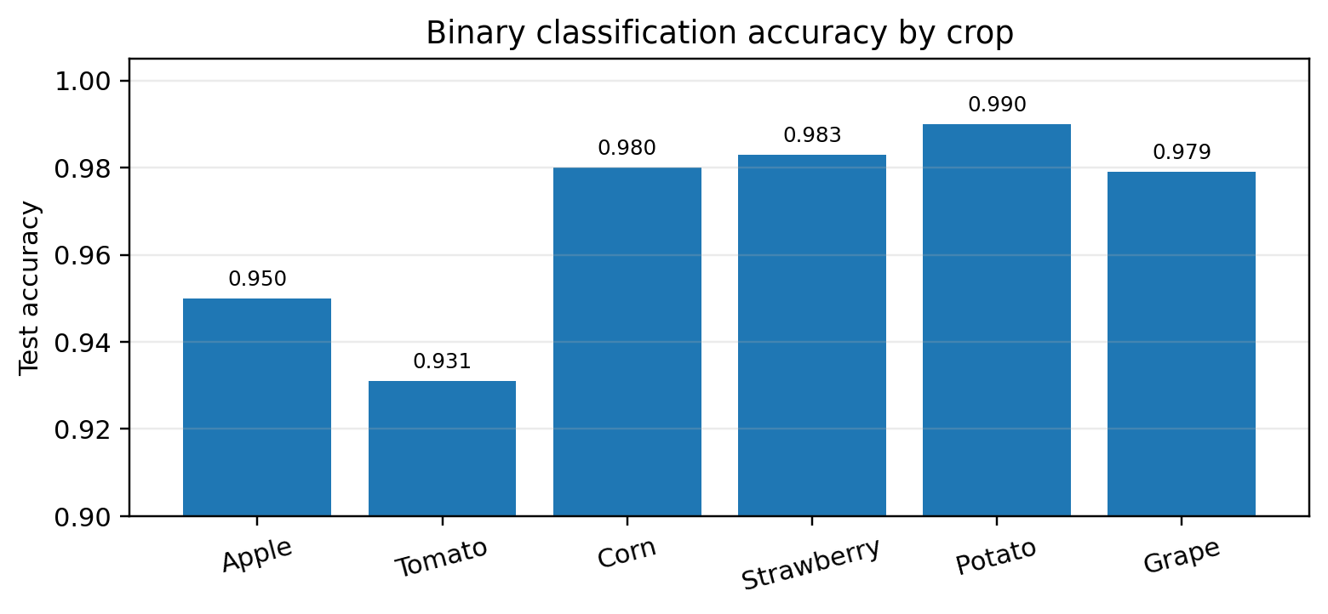
Figure 2. Test accuracy of the binary healthy/diseased classifiers.
Crop | Test accuracy
Apple | 0.950
Tomato | 0.931
Corn | 0.980
Strawberry | 0.983
Potato | 0.990
Grape | 0.979
Mean | 0.9688

Table 4. Test accuracy of the binary classifiers.

3.2. Crop-specific disease classification
Categorical classification was more challenging. With MobileNetV3Large, potato achieved the highest test accuracy (95.6%), followed by apple (93.3%), corn (91.1%), and grape (84.4%). Strawberry reached 73.0%, and tomato 70.0%. The mean accuracy across the six crop-specific classifiers was 84.57%.
Crop | No. of disease classes | MobileNetV3Large accuracy
Apple | 2 | 0.933
Tomato | 6 | 0.700
Corn | 3 | 0.911
Strawberry | 4 | 0.730
Potato | 2 | 0.956
Grape | 3 | 0.844
Mean | — | 0.8457

Table 5. Test accuracy of the crop-specific categorical classifiers.
For the two lowest-scoring crops, EfficientNetV2B2 improved strawberry accuracy from 73.0% to 80.1% (+7.1 percentage points) and tomato accuracy from 70.0% to 75.5% (+5.5 points). However, the model size increased from approximately 12 MB to 35 MB and inference time rose by about two seconds.
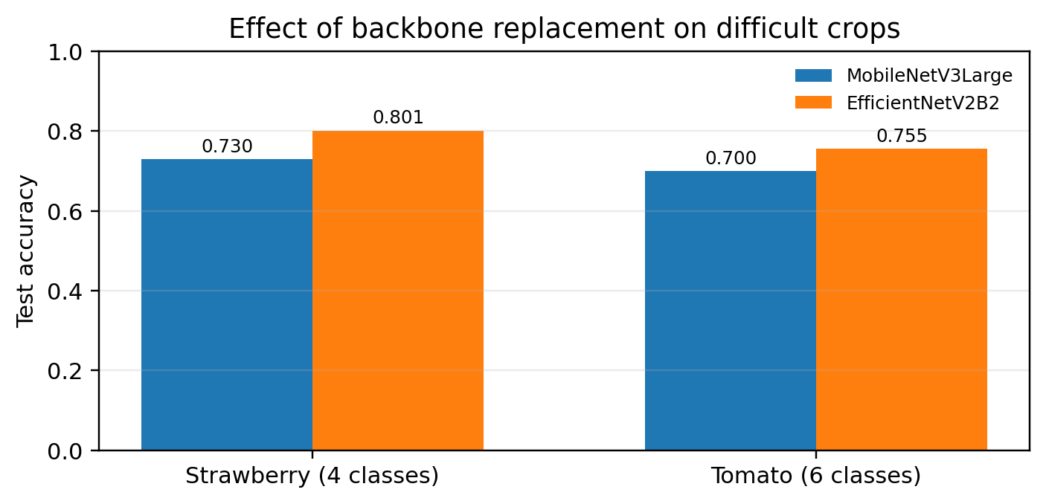
Figure 3. Categorical classification accuracy before and after replacing the backbone for strawberry and tomato.

4. Discussion
The experiments show that separating the task into binary and categorical stages is effective. Binary classification reached 96.88% mean accuracy, while detailed disease recognition reached 84.57%. The difference reflects the greater difficulty of distinguishing between several visually similar disease classes.
Tomato and strawberry produced the lowest categorical scores. Tomato had six disease categories and strawberry had four, but class count alone does not explain performance. Differences in visual symptoms, image quality, and class similarity may also affect recognition.
EfficientNetV2B2 improved accuracy for the two most difficult crops, but its larger size and slower inference are important disadvantages for a mobile application. MobileNetV3Large therefore remains a practical baseline when device constraints are prioritized.
The results should be interpreted in light of domain shift. PlantVillage images are relatively controlled, whereas field photographs vary in lighting, background, camera quality, and leaf orientation [1]. The reported scores should be viewed as experimental results on the evaluated data, not as a guarantee of performance in all field conditions.

5. Conclusion
A two-stage deep-learning pipeline was evaluated for plant disease detection from leaf images. The binary classifiers achieved 96.88% mean test accuracy, and the crop-specific categorical classifiers achieved 84.57%. EfficientNetV2B2 improved performance for strawberry and tomato, but increased model size and inference time. For a mobile application, MobileNetV3Large provides a reasonable balance between classification quality and efficiency.

References
[1] Mohanty, S. P., Hughes, D. P., & Salathé, M. (2016). Using deep learning for image-based plant disease detection. Frontiers in Plant Science, 7, Article 1419. https://doi.org/10.3389/fpls.2016.01419
[2] Howard, A., Sandler, M., Chu, G., et al. (2019). Searching for MobileNetV3. Proceedings of the IEEE/CVF International Conference on Computer Vision (ICCV), 1314–1324. https://doi.org/10.1109/ICCV.2019.00140
[3] Tan, M., & Le, Q. (2021). EfficientNetV2: Smaller models and faster training. Proceedings of the 38th International Conference on Machine Learning, PMLR, 139, 10096–10106.
[4] He, K., Zhang, X., Ren, S., & Sun, J. (2016). Deep residual learning for image recognition. Proceedings of the IEEE Conference on Computer Vision and Pattern Recognition (CVPR), 770–778.
[5] Ronneberger, O., Fischer, P., & Brox, T. (2015). U-Net: Convolutional networks for biomedical image segmentation. Medical Image Computing and Computer-Assisted Intervention – MICCAI 2015, Lecture Notes in Computer Science, 9351, 234–241. https://doi.org/10.1007/978-3-319-24574-4_28
[6] Aleinikov, A. F., & Klimenko, K. V. (2026). Early detection of a complex of plant stresses using computer vision [in Russian]. Siberian Herald of Agricultural Science, 56(7), 89–103. https://doi.org/10.26898/0370-8799-2026-7-10

